V-NC1205

Protecting What’s Important To You!

Place the Focus on Learning
No one knows better than educators that schools have become increasingly vulnerable to crime and violence. Safety concerns take up too much time and attention.

With Sonitrol, schools can put the focus where it belongs: on learning. Our solutions limit unauthorized access during, and after school hours. Serving over 12,000 schools, Sonitrol is an expert at assessing your school’s vulnerabilities, and recommending appropriate solutions to secure your facilities, and the students, faculty and staff inside them.

Serving Schools for Over 50 Years Sonitrol has been providing comprehensive security for the educational community for over 50 years. Today, Sonitrol is one of the largest providers of security systems to schools in the United States. We are the first choice of
educators because they know that Sonitrol means:
- Lower false alarms
- Fast police response
- Consistently high rate of apprehension
- Fully integrated protection against fire, theft, vandalism and intrusion
Customized Security Solutions

Intrusion Alarm Access Control
Video Surveillance Fire Detection
Panic Button Lock Down
Mass Notification Intercom

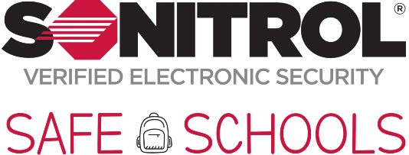
Key Statistics:
- A school is 3X more likely to be burglarized than a business
- Each hour of every school day 900 teachers are threatened and more than 2000 students and nearly 40 teachers are physically attacked on school grounds

Security Solutions for Educational Facilities www.SonitrolCarolinas.com
704-423-1111

Why Schools Choose Sonitrol
- Industry Expertise – You need someone you can trust. Sonitrol has worked with over 12,000 schools across North America.
- Innovative Technology – Sonitrol’s state-of-the-art audio detection technology is superior to anything on the market today. Complimented with video, fire protection, and managed access control, Sonitrol can offer a full suite of security protection.
- Proven results – No one can match Sonitrol’s results; the numbers speak for themselves. Criminals apprehended: 177,461 and climbing.

Sonitrol Performance Guarantee
No other security provider will match Sonitrol’s Performance Guarantee:
- $10,000 Performance Warranty – Sonitrol will pay for the first $10,000 of any loss if a forced entry is not detected and the proper authority is not notified.
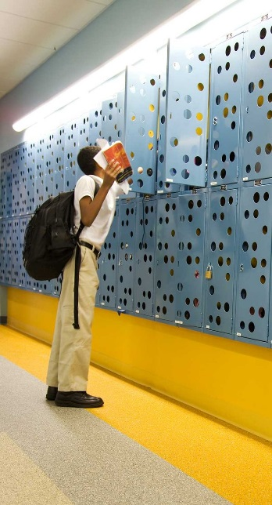
- Unconditional Satisfaction Guarantee – Sonitrol will refund your installation fee and remove our equipment if your system fails to perform as contracted and you are dissatisfied with our service within three (3) months of initial installation.
- False Alarm Fine Guarantee – If you receive a false alarm fine dispatched by Sonitrol and not your personnel, Sonitrol will assist in canceling the fee or credit your account for the fine.
- Emergency Service Guarantee – Within our service area, Sonitrol guarantees the on-site arrival of a service technician within four (4) hours from the time of your request.

One Simple Log-In
Anywhere, anytime access to all of your key security functions – all from a standard web browser. Just type in mySonitrol.com, and you can monitor all of your connected facilities.
- Intrusion Detection – View alarm messages and statistics specific to your burglary system.
- Online Access Control – Manage your users and their permissions or view your access control configuration.
- Video – Access live video feeds from any web browser or receive video clips via email.
- Fire – Review alarm history and key parameters specific to your fire system.
- Real-time Reporting – Get reports when you want them or scheduled to run automatically.

“Over the years, we have built a trust and partnership with Sonitrol that has enabled us to proactively
invest in the latest security technology to protect our students, staff, visitors, and property in a non-intrusive, discreet manner.” – Director of Risk and Safety, Milton Hershey School
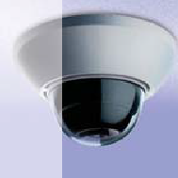
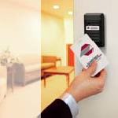
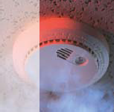
Sonitrol Services

Verified Audio Detection
Sonitrol detects the intrusion early and can often prevent break-ins before they occur
SonaVision Video Surveillance
Stop break-ins by leveraging the power of video surveillance to see criminal activities
Managed Access Control
Stop re-keying locks – take control of who accesses your location
Fire Detection
Around the clock monitoring of smoke and heat detectors, sprinkler systems, and pull stations
